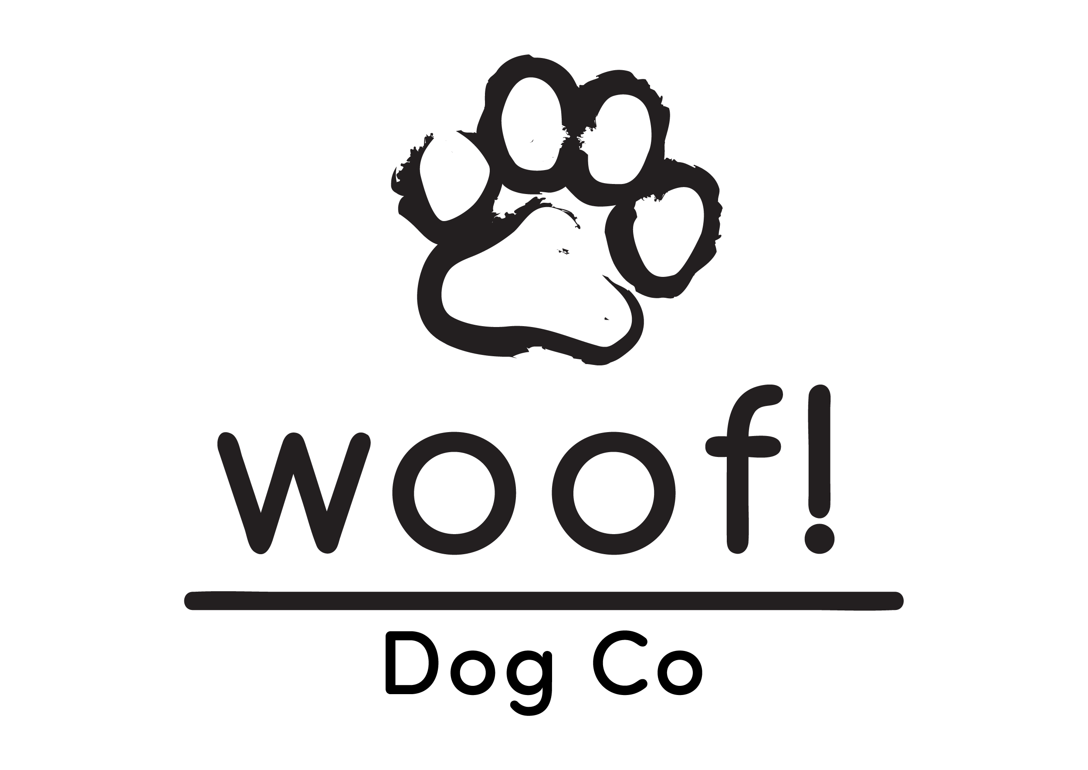

Woof’s Terms and Conditions Policy

By allowing or organising your dog to participate in the services we provide, and/ or by signing our enrollment form; you accept, agree and understand the following terms and conditions:
We feel it’s important for you to know that although we do everything we can to ensure the safety and happiness of your dog, there are some risks involved with our activities that you should be aware of- risks most of which are present in every day life for your dog in situations they will be in, even out of daycare, boarding or any other of our activities.

- SEX We require all males, over the age of 6 months, to be neutered and do not take females in season.

- AGE Only dogs over the age of 6 months are accepted. We have a Puppy Socialisation programme available for dogs under 6 months of age.

- VACCINATIONS We require all pets to be fully vaccinated (including kennel cough) prior to joining. Dogs must have had their Kennel cough vaccination at least 5 days before their attendance date.
A copy of each dog’s vaccination record will be kept on file and updated annually.

- HEALTH Owners will need to clarify that their dogs are in good health and that they do not have any potentially contagious conditions. Eye infections, stomach upsets and coughs can be spread easily. We MUST be made aware for the sake of the other dogs. Your pet must be enrolled on a flea/ worming programme and be vaccinated against Kennel cough.

- LEADS & COLLARS Legally, all dogs should wear a collar with a name-tag in public. Whilst at Woof All dogs are required to wear a well fitted collar or harness at all times.
The boundary of Woof Is a 4ft-meshed fence. If your dog is likely to be able to jump this or has the tendency to want to escape, your dog must be kept on lead at all times whilst at Woof!.
We are bordered by acres of fields and farmland which is home to many rabbits, foxes, sheep and deer. If your dog has a high prey instinct and is likely to chase animals and livestock, we recommend they stay on lead whilst at Woof.

- LOCATION Our facility is a large fenced field with a log cabin for shelter. We spend the majority of the day outside walking, playing and socialising and down time in the Doggy Vans in between walks.
All dogs will walk in the field off lead unless recall is still being worked on, I which we will discuss with the owners. With any off lead environment, there is a risk to dogs security. We work hard to ensure that dogs get the greatest amount of fun, interaction and exercise while they are with us. Our dog walking field is totally secured by perimeter fencing, with a wire mesh and stands at around 4ft high. It is essential you tell us if your dog(s) would/ could try and jump this fence height, or has the tendency to escape/ bad recall, so they can be kept on lead. By organising activities with us, you accept these risks and agree not to hold Woof liable. Staff are with dogs at all times whilst in the fields and on walks to lower all risks of escape.
Dogs will spend their time with other dogs from other families. All other dogs are well vetted and go through a strict entrance and suitability procedure, to ensure we only have friendly and sociable dogs.

- FOOD All food bought along must be portioned and stored in airtight containers and marked clearly with the dogs name and surname, including date and feeding times/ instructions. We recommend if possible, feed your dog only before and after their session and not during the day.

- TREATS In order to provide your dog with a positive learning experience whilst at Woof, we will reinforce your dog’s good behaviour and ignore unwanted behaviour. Your dog(s) will be given treats supplied by you or Woof Unless otherwise instructed.

- BEHAVIOUR All dogs must be non-aggressive and not food or toy possessive. Owners will need to certify that their dog(s) have not shown aggressive or threatening behaviour towards people or other dogs. Woof reserve the right to decline or terminate a booking in any circumstance.
Dogs mixing with other dogs (including other sized dogs and dogs of different ages and breeds) is a vital part of their life and socialisation. During the time your dog is at/ with Woof, they will come into contact with other dogs in off lead and open space environment. In the vast majority of cases this is a hugely positive experience; however, as with any group interaction, this presents the risk of dog-on-dog aggression, fights, bites, accidents etc. By enrolling in our activities, you accept all of these risks and agree not to hold Woof liable. We ask owners to accept legal responsibility for their own dogs behavior, and assume any legal and veterinary costs to other dogs and property damage costs associated with their dogs behavior. By organising activities with us, you agree to cover such costs and allow us to pass over personal information to any official authority or to any other dog or property owners that have suffered as a result of your dog’s actions so that they may make contact with you. We will keep you informed of any altercation involving your dog, whether damage or injury occurred or not. We also reserve the right to dismiss any dog that shows dangerous or inappropriate behavior from all services at Woof with immediate effect, even if it is a one off or out of character. By organising for your dog(s) to participate in our services, you are confirming that your dog has no record of aggressive or anti-social behavior and you have made a full and frank disclosure of any characteristic or trait that might make their dog unsuitable for socialising with other dogs. If we feel that a dog does pose any risk to any other dog, even if you do not agree, we reserve the right to dismiss this dog with immediate effect. We will never take a dog into our services if we feel they pose any risk to people or other dogs and we reserve the right to muzzle any dog we think needs to be muzzled to prevent injury to our staff, the public, themselves or any other dog. Although these risks are always present within groups of dogs, we do everything possible to reduce the risks to as low as possible. Our entrance policy is strict and we refuse to accept any dogs that show signs of aggression or antisocial behavior, and dismiss any dogs showing signs of aggression from all activities immediately, no matter how long they have been attending.
Woof encourage positive learning and reinforcement by ignoring unwanted behavior and rewarding good behavior.

- ACCIDENTS, INJURIES AND ILLNESS We take the greatest possible care of all the dogs we are responsible for, however as stated before, injuries & illness can occur for a variety of reasons. Should your dog be involved in any incident, our staff will check your dog over for injuries, however our staff are not trained vets so we ask that you check over your dogs further at home or seek professional opinion. You agree not to hold Woof responsible for failing to spot that an injury or illness has occurred, or that the nature of the injury is worse than first realised. Should your dog show any obvious injury/ illness, we will inform you immediately (at any time of the day) and take your dog to the vet specified by you, or if not available, we will take them to our registered vets “Boness Vets in Flitwick or Barton Le Clay”. If we cannot get through to you, we will call the emergency contact number you have given on your enrolment form. If we cannot get through to the emergency contact number, we will hand over full authority of care to the veterinary hospital in what they deem professionally appropriate for the best care of the dog.
By organising activities with us, you give permission for Woof to authorise any treatment/ procedure etc that the vet deems necessary to carry out immediately or to prevent suffering, and agree to pay the associated fees or reimburse Woof for the full amount- including consultation or out of hours charges. This is to ensure your dog doesn’t suffer waiting if we can’t contact you before hand. We have Canine First Aid kits present at all times on location. This also applies when a dog shows signs of sickness or discomfort that we feel needs investigating by a vet- particularly if they are staying with us for a long period of time (more than 12 hours). We will always try to get in touch with you beforehand, but you authorise us to request investigatory procedures and surgery should it be deemed necessary before your dog is due to return to you. You agree to cover these costs in full directly with the vet, or reimburse Woof should we not be able to get in contact with you. We strongly recommend that you purchase pet insurance for your dog that covers them while they are under our care. It is important to understand that despite all our best efforts, dogs can get sick or injured for a variety of reasons. We believe in letting dogs be dogs and run around and play with each other and on a variety of surfaces and equipment. This can include raised objects and structures, grass, woodchip, bare soil and rocky areas that they could, for example, chew/ swallow/ cut themselves on/ jump from. We also have a variety of play equipment and toys on site that dogs have access to at all times. Although we make these surfaces and equipment as safe as possible, through play and interaction with these items and surfaces, there is a greater risk of injury than without them- however it also makes the field a more fun and interactive place for them to be. By using Woof, you accept this and will not hold us liable (financially or otherwise) for any injury, accident or sickness that occurs as a result of normal day to day participation in our services.

- ENROLMENT All dogs must have a complete, up-to-date and approved enrolment form on file. All dogs must undergo an initial suitability assessment and be approved by a member of staff. All dogs must attend the same booked/ reserved session each week. Additional sessions can be booked adhoc where there is availability and once we are happy they will fit into the new group as a one off session.

- TRANSPORT Our vans are professionally fitted with the highest quality cages and offer the safest way of transporting your dog- however vehicle transport always presents a small level of risk from collisions etc. and due to being unattended in the rear of the vehicle when drivers are driving or picking up/ dropping off another dog. You agree to allow us to transport your dog in any of our vans to any required location and agree to not hold Woof liable for injury or death caused by a road traffic collision or incident in our van/ car or another vehicle.

- KEYS & HOME ACCESS
Owners must give Woof team members a full brief of access to the house for walk or collection. Any keys needed must be well labelled and given to a team member. A member of Woof will follow your requested procedures for collection/ drop off at all times and will take all steps to ensure it is safe and secure, but we cannot be held responsible for burglaries or accidents/damage caused by your pets.
Keys will be securely kept in our own home when not being used for pick up/ drop off.

- FEES
Full Day (3x Adventure Walks) - £36 per dog
Adventure Walks - £17 for one hour
Pet Taxi - Prices on request
Clients must must pay for all services upon confirmation of booking, unless otherwise agreed with Woof.

- HOURS OF OPERATION
Monday – Friday 09:00 – 16:00

- CANCELLATIONS
Spaces are blocked out and reserved by you, for your dog. We ask that dogs must attend the same sessions each week. If there are times you are away or would like to adjust your space, we ask you give 2 weeks notice so we have chance to offer the spaces to other customers. Less that 2 weeks notice for cancellation with result in full charge.
This is also the case if you would like to adjust your usually day to another day that week, 2 weeks notice is required.
14 days+ notice = No Charge
Less that 14 days notice = Full charge (Customer owes full booking price)

30 days+ notice = No Charge
Less that 30 days notice = Full charge (Customer owes full booking price)
By signing the Woof enrolment form, I certify that I have read the Terms and Conditions and understand, and agree and intend on my own behalf, and on behalf of my agents, representatives, relatives, successors, and assigns, to be bound by all the terms and conditions contained in the above.

